Reverse documentation.

The program is designed to take text input from the user, and then print the lines out in reverse order. The lines themselves aren’t reversed, just the order of printed lines.

The program is used from the shell, and there are two parameters available: <input> and <output>. Input specifies a file from which the text contents get read. Output specifies a file where the reversed lines will be printed. If output is not given, reversed lines will be printed to stdout. You can also run the program without any parameters, in which case the text input gets taken from stdin, and outputted to stdout.

The program uses a doubly linked list to keep track of the lines of text. When the input is finished, the program simply prints out the contents of the list in reverse order into the desired stream. Stdout and stdin behave the same way as a file stream, so the same subroutine can be used for all purposes.

I needed to create some error handling to make sure the program is as stable as possible. The basics were quite easy, such as checking if the input and output files are the same, or if an input file doesn’t exist, but there were some more problematic ones as well. One of the more tricky ones was handling the case where the user starts the program without any parameters, doesn’t give any lines of text, and just closes stdin. This caused a segmentation fault, which was hard to pinpoint, but I managed to create a check for this case. I still know of one error in the program, which I haven’t handled. If you give an input file which is not a text file (such as “reverse” itself), the program doesn’t know how to handle the input. I could work around this by adding a check where the last 4 characters in the file name has to be “.txt”, but that only accounts for plain text files, and then you couldn’t reverse for example the html files. Detecting if the read input is text or not seemed to be possible, but it was too complicated to implement into this project.

The repository for the source code is available on GitHub: <https://github.com/Ketsuppimakkara/Systeemiohjelmointi-Project-1>

Screenshots

Figure Using reverse with stdin

Figure Using reverse with an input file

Figure Using reverse with extra long strings

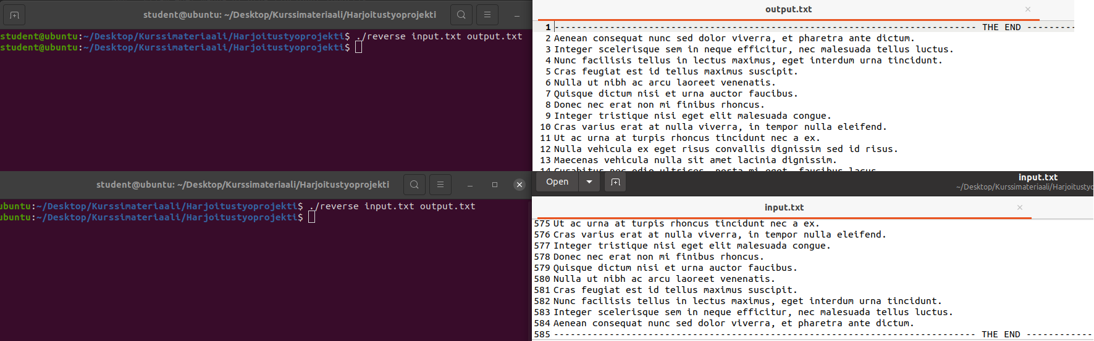

Figure Using reverse with two files, with some 580 lines.